**AWS elasticbeanstalk and cloudwatch 5/7/24(Friday) addi sess**

**Cloudwatch:**

* **To monitor the ec2 memory ,we create custom matrix.**
* **Before that create ec2 instance**
* **This is default matrix**

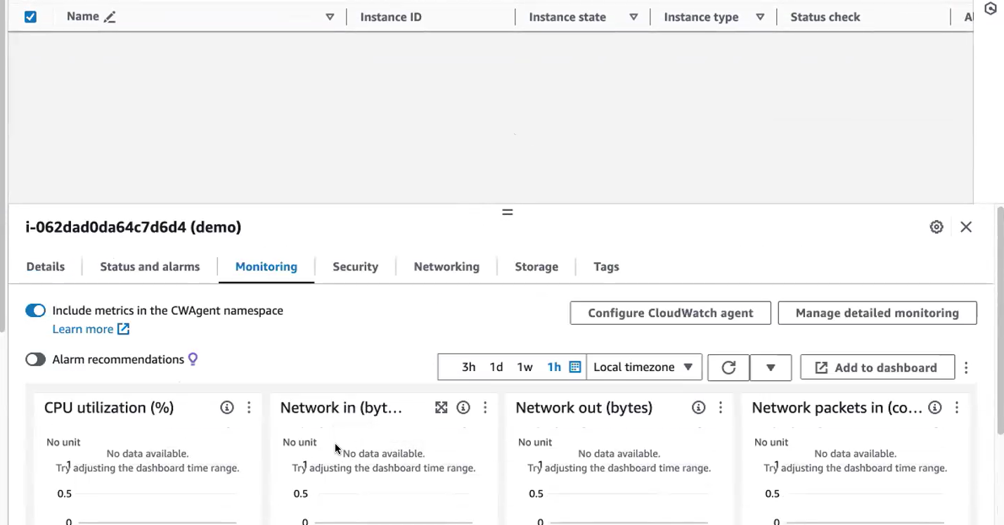

**Creating custom matrix:**

**before creating your custom metrics, we want our cloud watch to monitor this Ec. 2 using the custom metric. For that we have to install a tool. We will be installing cloud watch agent. We call that as Cloud Watch agent. So with the help of Cloud Watch agent, we can create custom metrics to monitor your Ec2, memory.**

**Connect with ec2.give the command to install amazon Cloud Watch agent**

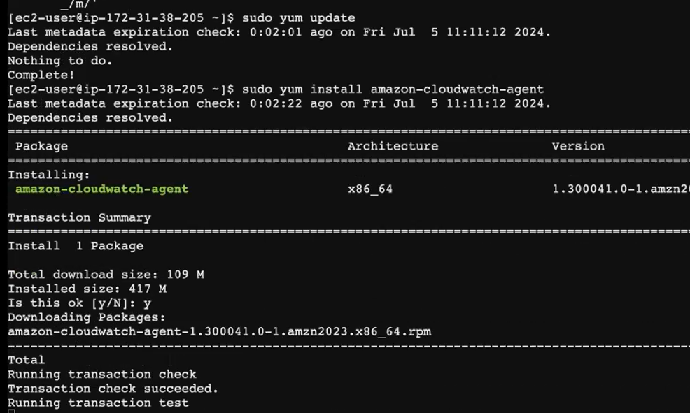

**Link for install a.c.w other than linux**

[**https://docs.aws.amazon.com/AmazonCloudWatch/latest/monitoring/install-CloudWatch-Agent-commandline-fleet.html**](https://docs.aws.amazon.com/AmazonCloudWatch/latest/monitoring/install-CloudWatch-Agent-commandline-fleet.html)

After installing the cloud watch, we have to create the metrics. Okay, so you have to create the metrics and that metrics will be created in your Cloud watch agent dashboard. So what I do, I will create a **metric. We we can write. You can create this using python /shell scripting or any scripting language you can use.**



#bin/bash

Instance-id= copy and paste

Namespace=anything we give

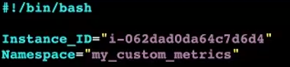

**what this metric should do, it has to. We have to. We have to monitor the memory utilization. So I will create a variable called mem.So this variable what we are doing using the free command, this free command will display you the system memory information.**

**I'm only filtering the line containing my memory information that does my RAM information. Okay? So next, I'm further filtering out using my awk command. So this this command what it does, it will calculate the percentage of used memory. Okay, it will calculate the percentage of used memory, and I am formatting it to 2 decimal places 0.2f/n**



**when this script is executed, my metric will be created. Okay. So when this script is executed, this memory variable will be created, and it will be holding this value. But what I want to, I want to create a metric.**

**I want to create a metric in my cloud watch dashboard. So it's like creating a resource. You're creating a resource in the cloud watch. We are creating a custom metric for that I use aws command. I use aws cli.** **You have aws, cloud watch, so aws cloud, watch, command will help you to create a metric in your cloud watch dashboard.**

**going to create a metric in the cloud watch dashboard. So how do I create a metric using this keyword metric data I'm going to publish, or I'm going to create a custom metric. give any name for my metric**

**Aw cli command to create your metric. So while creating a metric, you give the val name of your metric, and in which namespace your metric should be created. and what is the instance that it has to monitor the resource, what it has to monitor? We put it under dimensions and value what it has to what value it has to return. Okay, so what it has to monitor, or what this metric has to perform, it has to perform the memory utilization in my Ec. 2 mission.**



**So before executing this script in this script, what I have done, I have used. Aws cli. So 1st we will install Aws Cli.**

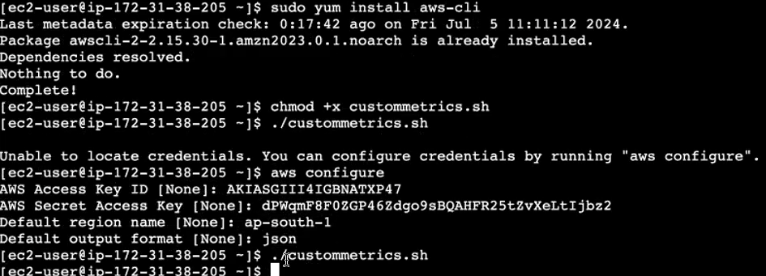

**Access key and matrix access key was generated only by IAM users. Then execute the script.**

**How to check custom matrix created or not**

**Click cloud watch**

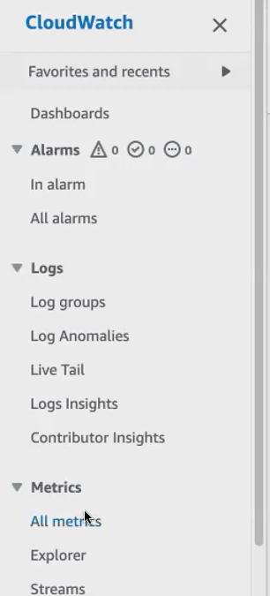

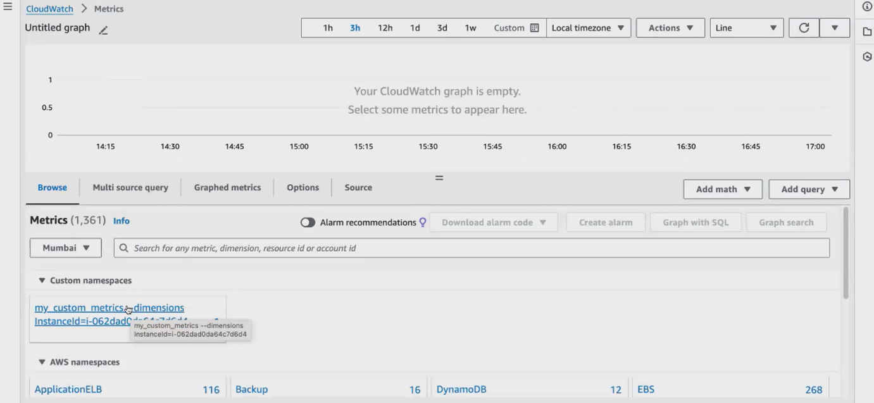

**Click on the matrix,see the memory utilization. Click create alarm [whenever attain threshold value for our memory create alarm]**

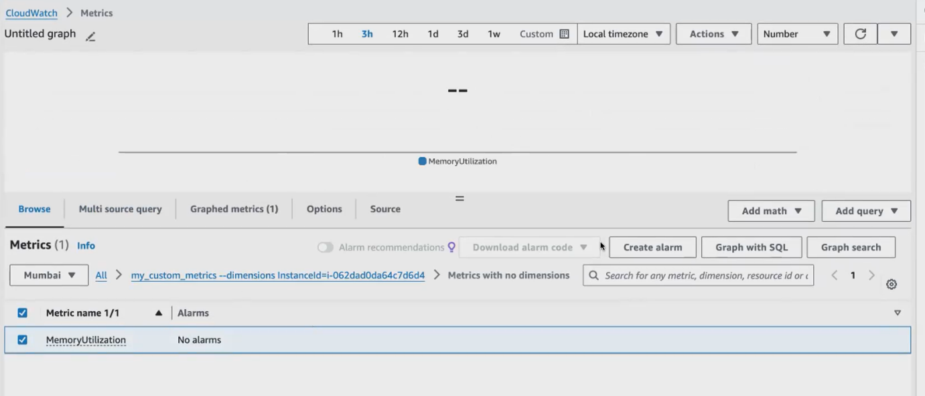

**Give threshold value as 10.** **threshold value, it will send you a notification**

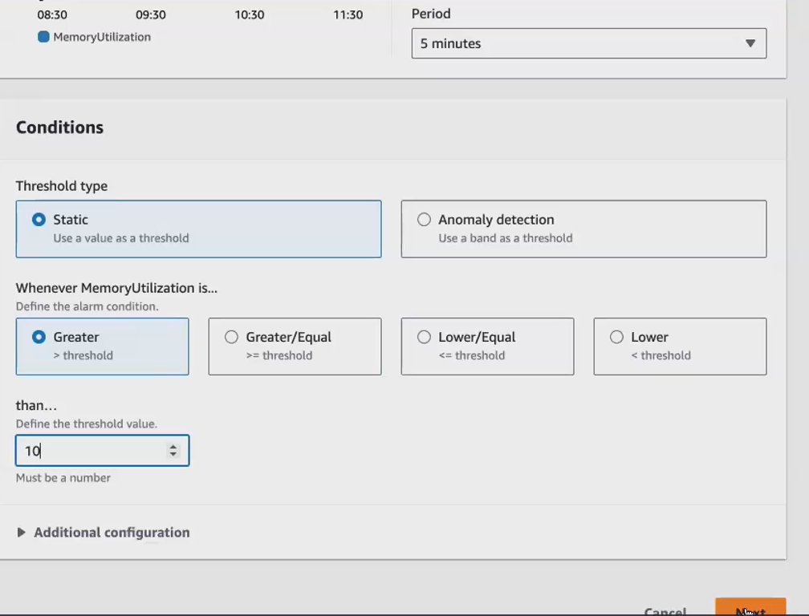

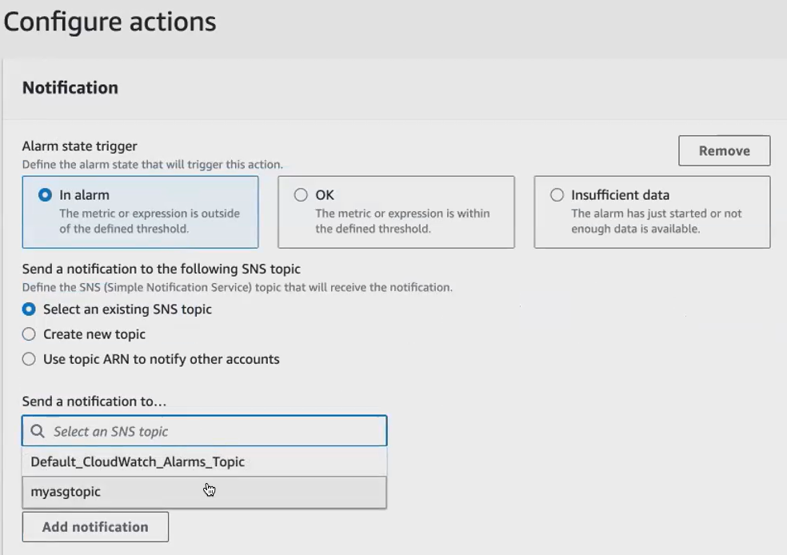

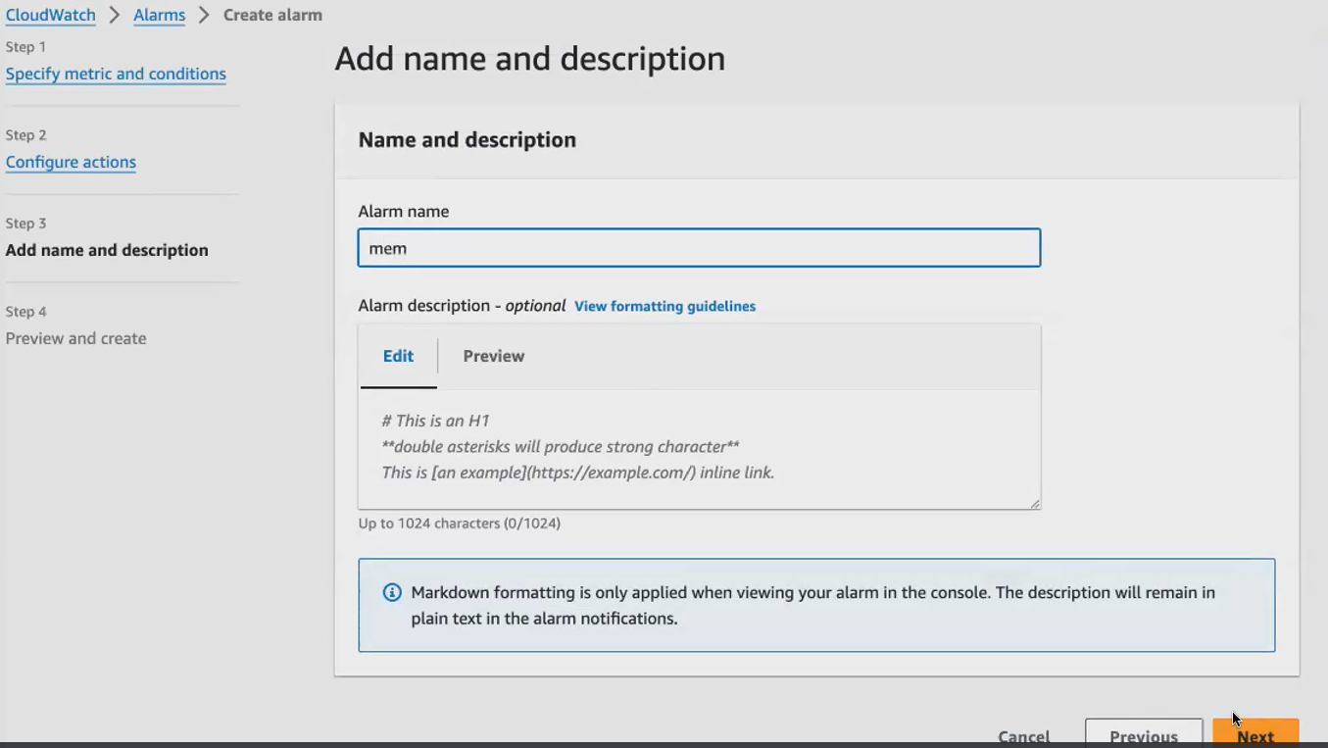

**Alarm has been created**

You can see the metric that we have created, and you can see the namespace under the namespace. You will have the metrics. So under your namespace, you can have multiple metrics. So now I have created only one metric. Same way. You can create multiple metrics. So you can see under cloud watch under using aws. Cloud watch put metrics. I've created only one metric. So in the same way, I can create multiple metrics to monitor the memory itself.

you can have a namespace under a particular namespace. You can have multiple metrics. So here, if you see here, under your custom metric.so under these are, you can see in the bottom. You have Aws, namespaces which are default namespaces. Okay, so you can have under Ec. 2. This is the namespace, Ec. 2 is the namespace. These are default namespaces. So for the custom namespace for the custom metric. We have created the namespace, and we have given this as the name. So under your namespace, you can have multiple metrics.

**you can monitor your ec2 the same way. You can also monitor your application:**

**we will create a small application in this ec2.** So before monitoring, using your cloud watch what we do, we will create an application. We will launch a simple Apache application. Let me run the script to launch the application. You can use if you have any old script that I've given shared with you, you can use the same script. Also think for launching the website we used. We used a script. Right? We can use the same script here.I think, in the load balancer document, you can find it load balancer or the user data document. You can find it because in the user data will be using shell script only to launch the website. So we can use the same script here. Let me also copy the same script, and I will just put it heresaid, because to monitor the application, you need to have an application running.

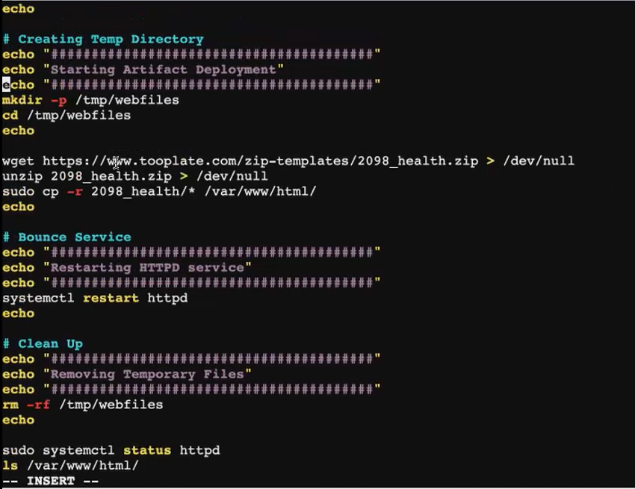

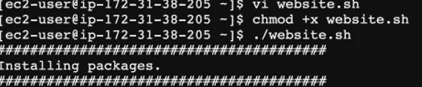

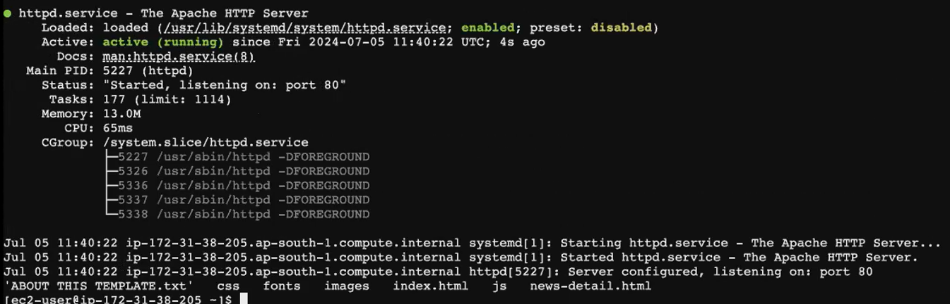

**Webserver is running**

**Now you can see Apache is running. Now the Apache we have installed Apache, and the application is running inside my Ec2. Now, what we do even create a metric here. So before creating your custom metrics make sure to install Cloud Watch Agent. Since we have already installed Cloud watch Agent for checking the memory. I'm not installing it, but whenever you're creating a custom metric, make sure you install the Cloud Watch agent, and whichever ec2 you are monitoring it.**

**now I will create a shell script to create another custom metric. This is to monitor the application. So, using this metric, we saw how to monitor the infrastructure, using your CPU, your system, how to monitor your Ec2. Now we will see how whether this is to monitor your application that is running inside the Ec2.**

**I have used. Instance id here you can hard code your Id. Okay, you can hard code your instance, Id or you. You are not sure about the instance Id, because in real time we will be launching our instances** **through terraform. his command you will be using  http 169.254 give complete detail about ec2.**

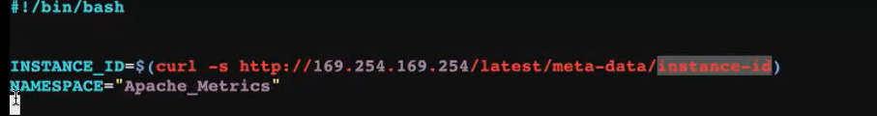

**I'm creating function. This function name can be anything you can give any name for your function.Any name you can give, but at the end you have to give a open parenthesis and close parentheses. Since I'm using shell script you. Just this is out in the shell script. We create a function. So what this function should do, this function will check if my Apache application is running or not.**

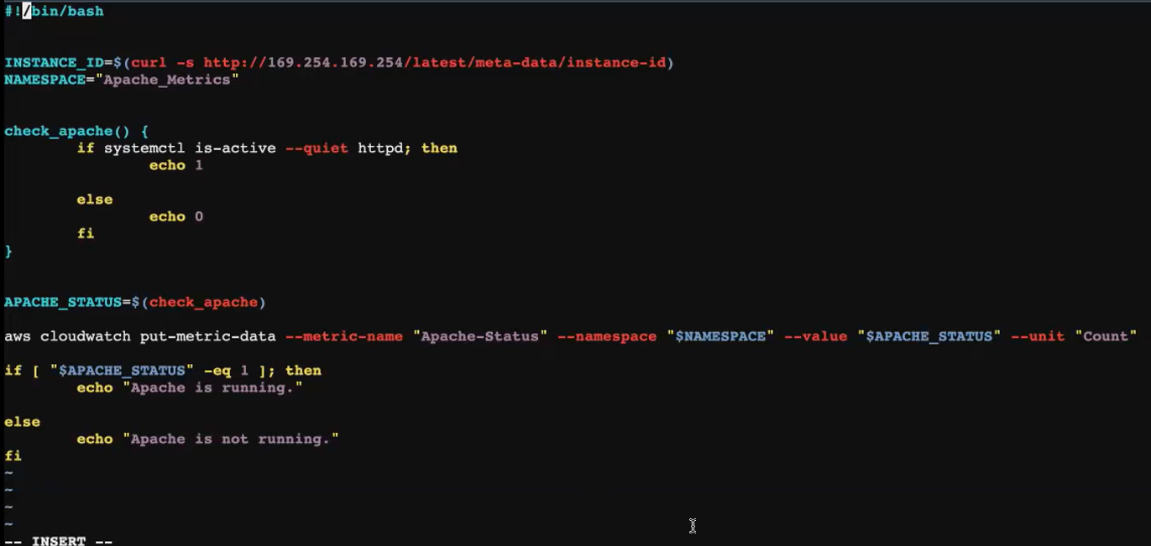

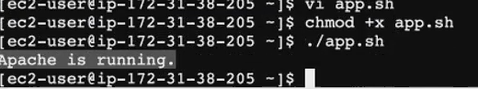

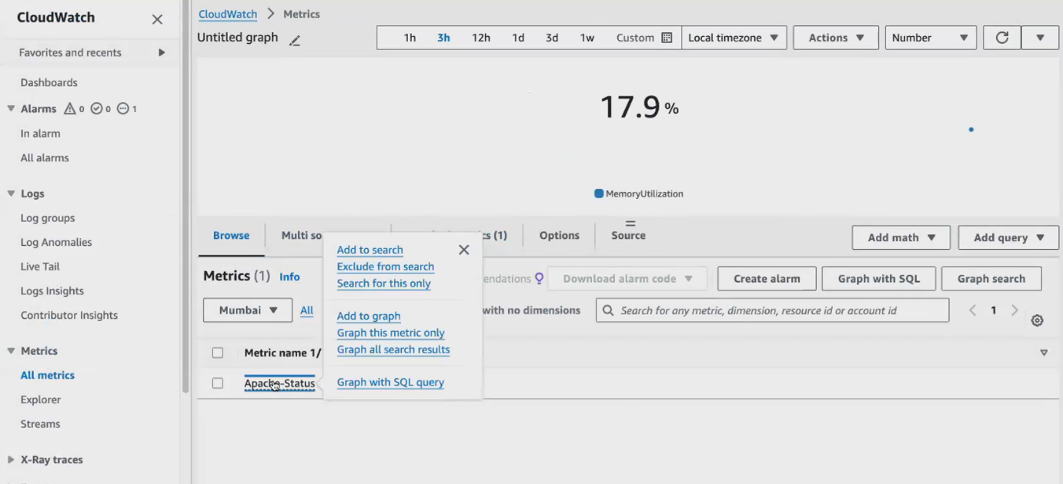

**Apache custom matrix created**

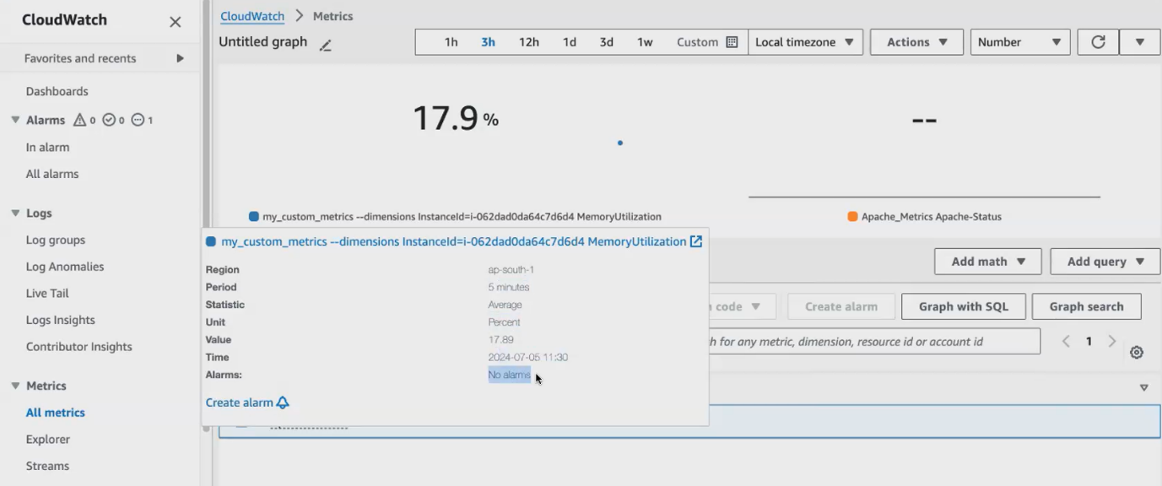

[**https://docs.google.com/document/d/1PaEBggi56c6DFcw9MVqt0gN5kDOr0Z8z0XLuT_CmAtU/edit**](https://docs.google.com/document/d/1PaEBggi56c6DFcw9MVqt0gN5kDOr0Z8z0XLuT_CmAtU/edit)

**link for cloud watch scrpting**

**if you want to monitor your Ec2, you can write a custom metric, but mostly we. We don't use the custom metrics. Rather, we will use the default. Metrics itself. Aws has got lot of default metrics. We will make use of those metrics itself in case if you want to create your own metric.**

**Elasticbeanstalk:**

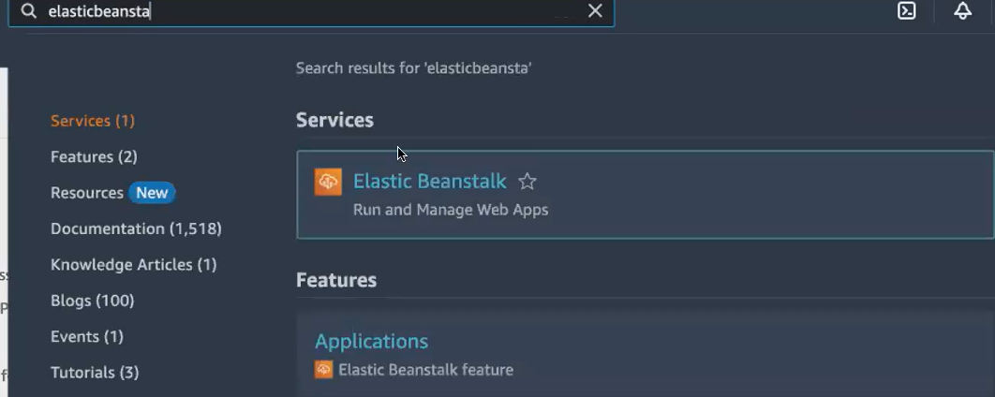

**it is mostly used by your developers rather than the devops engineer or the operations team. So your developers what they do, they develop the application. But they are not aware of the deployment part. So like the Devops engineer will do the deployment or the operations team will be doing the deployment. Okay? So here, what they can do, your developer. They themselves can deploy the application if they want to deploy it in the Aws environment, they can. They themselves can deploy it in the Aws environment using elastic beanstalk. Okay? So what elastic beanstalk does it will give you a end to end application management platform.**

infrastructure as service platform [ec2,s3]

platform as a service [ **Elasticbeanstalk]**

platform as a service means **it also gives you the infrastructure along with the infrastructure, It provides us the platform also.**

**Example: Now, I've launched a Apache application. Okay? So what I did, I created an Ec2 . inside the Ec. 2 I installed WGet command to install Apache 2 then Unzip? So I install all those tools before launching my application.**

**myself set up the environment to launch the application. But if you're using elastic being stuck. You don't have to worry about setting up the environment. So you get the infrastructure along with the infrastructure. You will also get the platform. You just need to have the application. Okay? So what we do, we will completely configure everything in the console.**

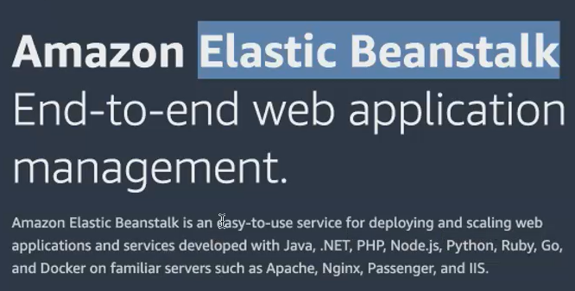

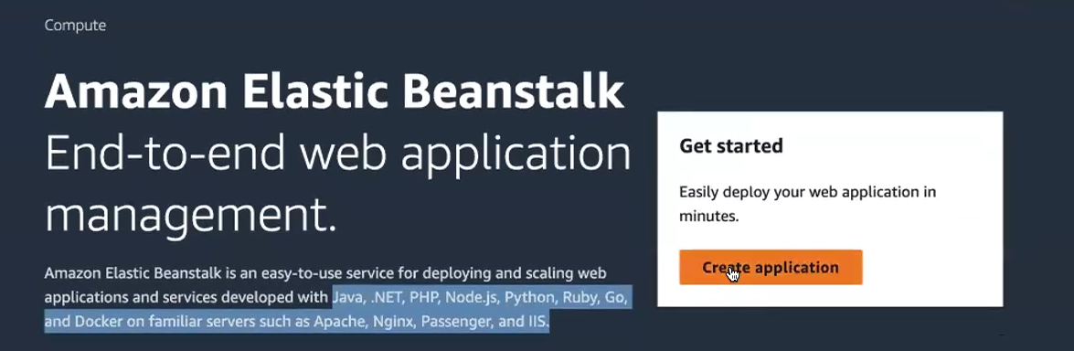

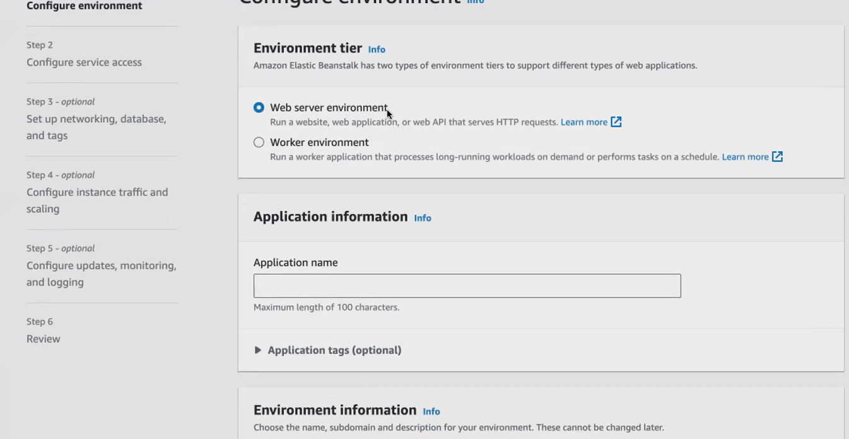

Either you want a web server environment or a worker environment .so we we mostly go with if you're using a web application, you go with web server, environment worker environment is for the batch processing. If you're running any heavy workload or batch processing, you go with worker environment. But mostly we go with only web based applications. So you use web server environment. Okay? So this web server environment can use application can run the application which is accessible by Http and Https request. Okay, so you give your application name your wish.

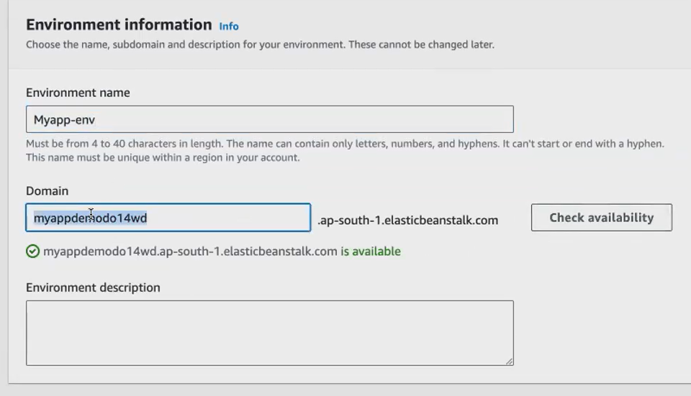

After give domain name check availability .then only shows green colour.

you have to select the platform type. As I told you, your elastic beanstalk gives you the platform to run your application. Now, what the developer will have developer will have only the application. so my developer can have a Java application. Node Js application or a python application. So based on his application, you have to select the platform. So if I'm using a node Js application. I have to just select the node Js platform and the platform branch I can select which branch he is using, so my developer will know whether he's using Nodejs 2018, or 17, so he can pick the version accordingly, and and the platform version

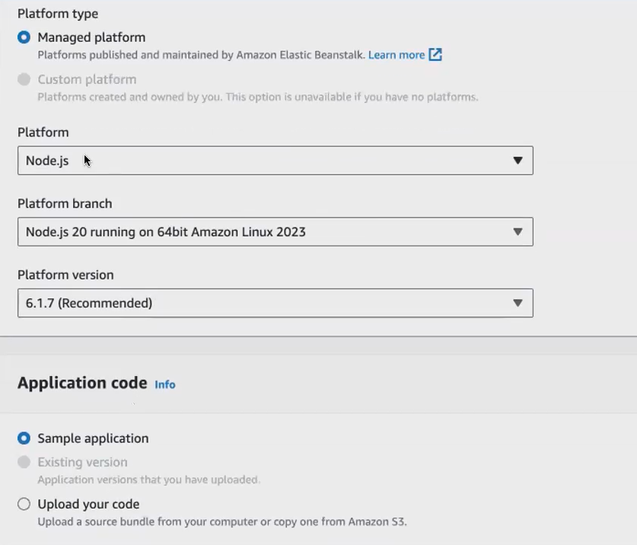

**it will launch an ec2 inside the Ec2 , it will install a Nodejs application.**

**if I give you a Nodejs application, what you will do first, you have to set up the environment, you have to install Nodejs, and then you have to run the application in that Ec 2.** So same thing, your elastic bean is doing it, for you just have to select the platform. You don't have to worry about configuring the platform in the Ec. 2. You just select the platform name and the version next you can. If you have the application. If I have the Nojs application, I can just upload it here. Okay, I can just upload my Node js application here.

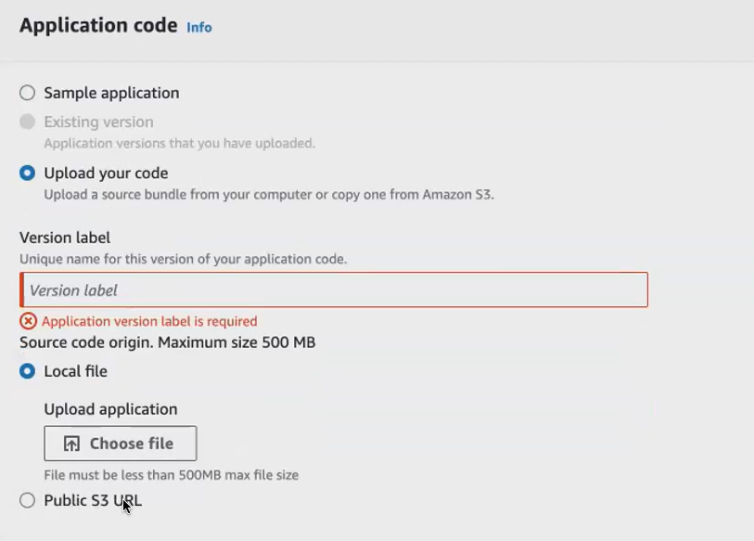

**If we have code inside local machine just upload it or give sample application. Now we give sample application.**

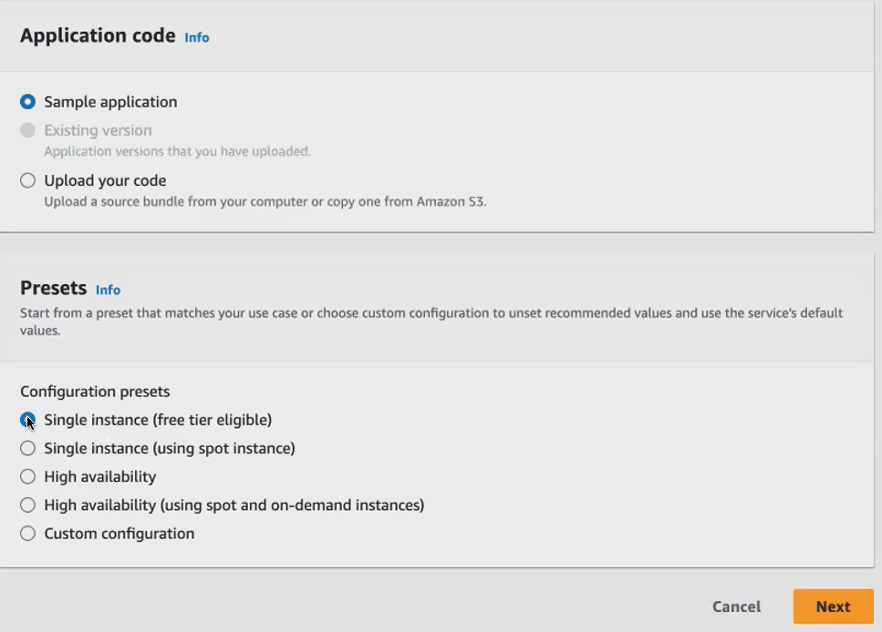

**your elastic Beanstalk will launch an Ec2. So your elastic beanstalk is a different service, and your Ec2 is a different service, my elastic beanstalk wants to talk with my Ec 2. We have to create a role. We have to create a service role. So only with the help of service role. Your elastic beanstalk can connect with your easy to ec2.**

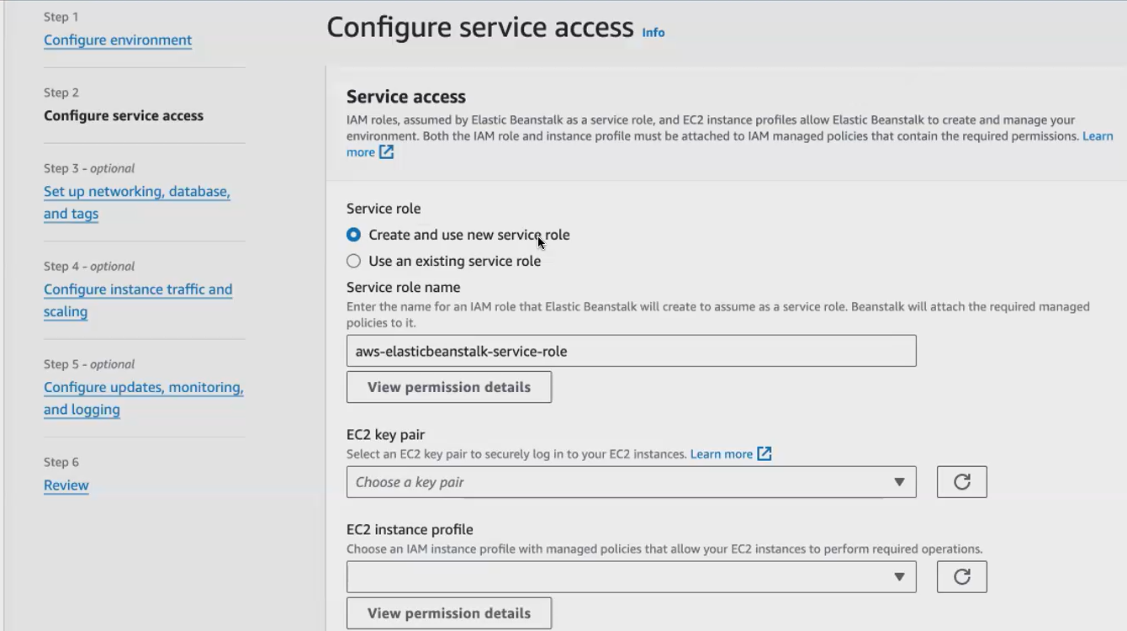

**1st time give create new service role in IAM user.**

**Here yasmin give already created role**

**here in the elastic beanstalk, I am creating 2 IAM role, 1 1st IAM role is for the elastic beanstalk that you get it by default from the elastic beanstalk itself. You don't have to create it manually, wherein the second IAM role is for the Ec. 2. Okay? So your Ec 2 should set the elastic bean stocks application deployment. So for that, I go to my IAM go and click on roles. So we will create a role aws services.**

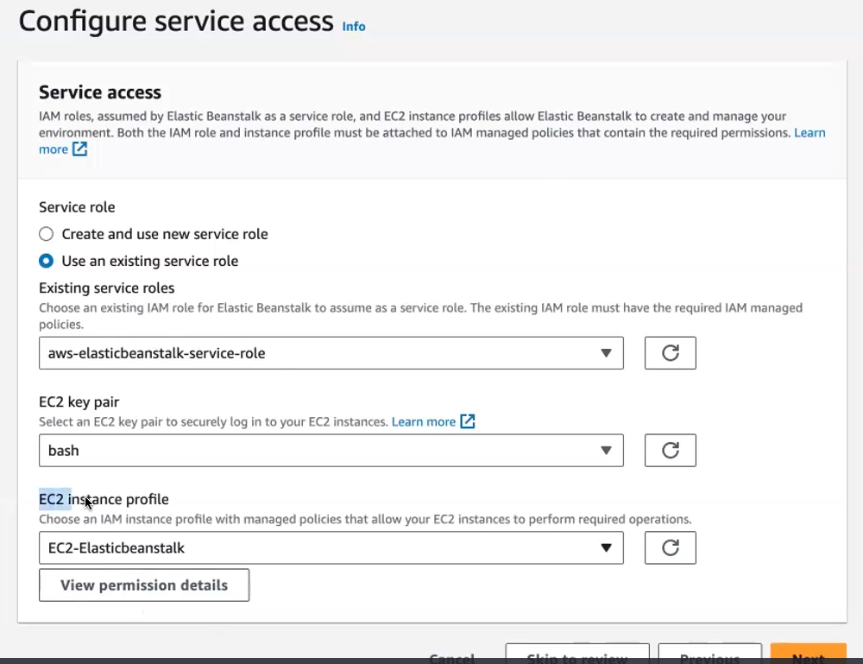

**have to give click on the view permission details. So I have to give elastic bean stalk webtier****, elastic bean stalk worktier , , elastic bean stalk multi-tier container docker, okay, these 3 permissions I have to attach for this iam rule.**

**Goto iam user 🡪 roles🡪create roles**

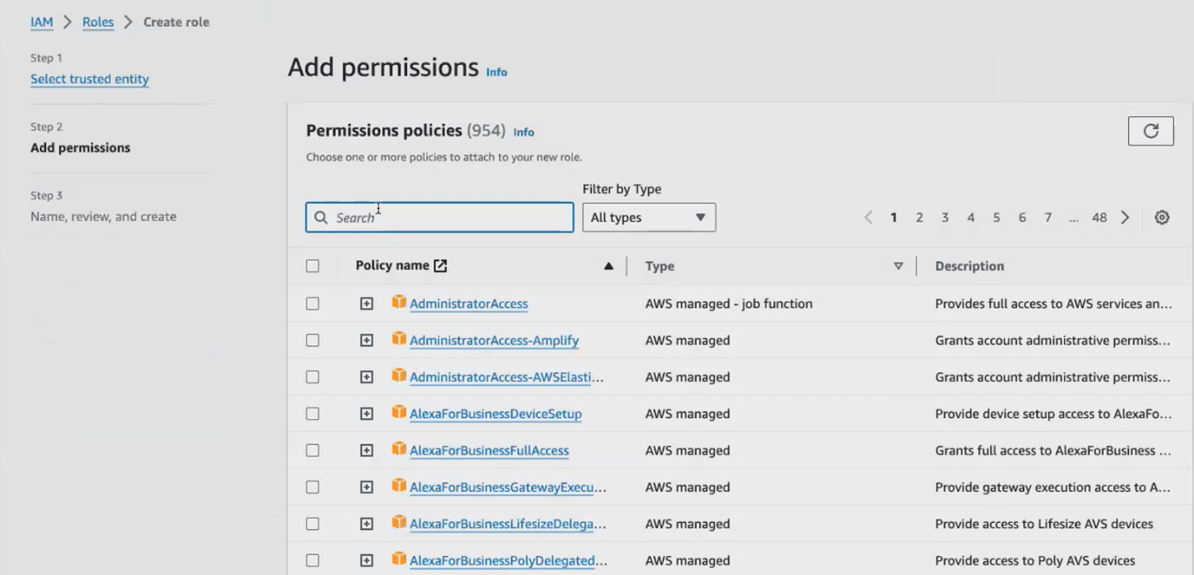

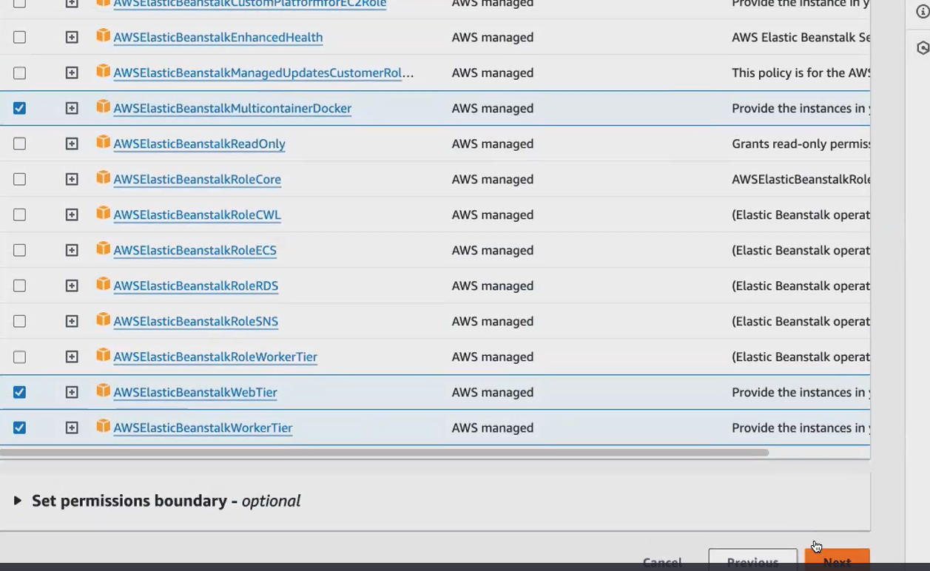

**Click next.give role name**

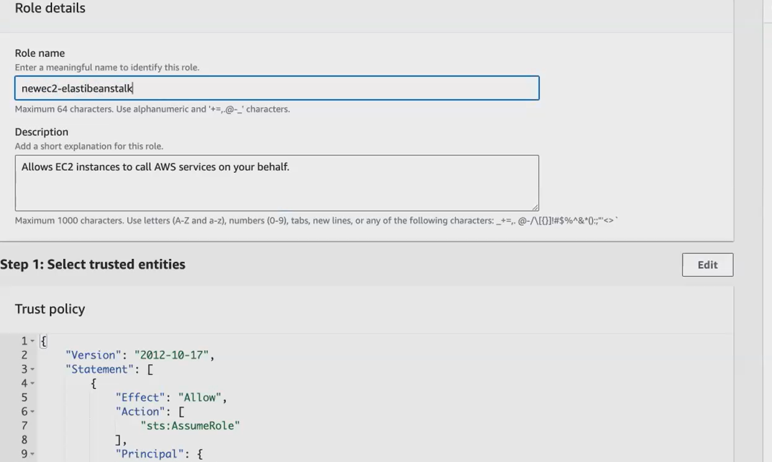

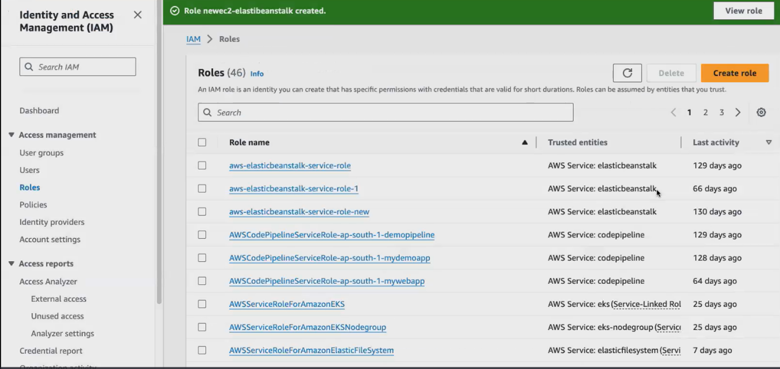

**Role created.use this role in e.b.s**

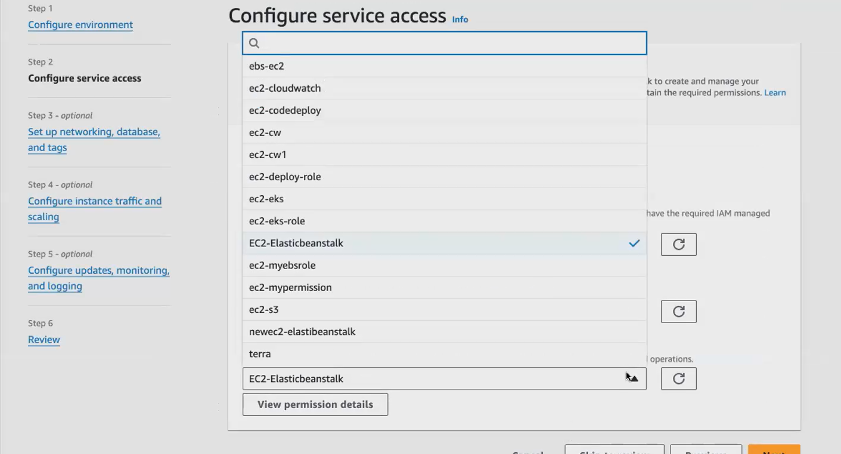

**Select default vpc**

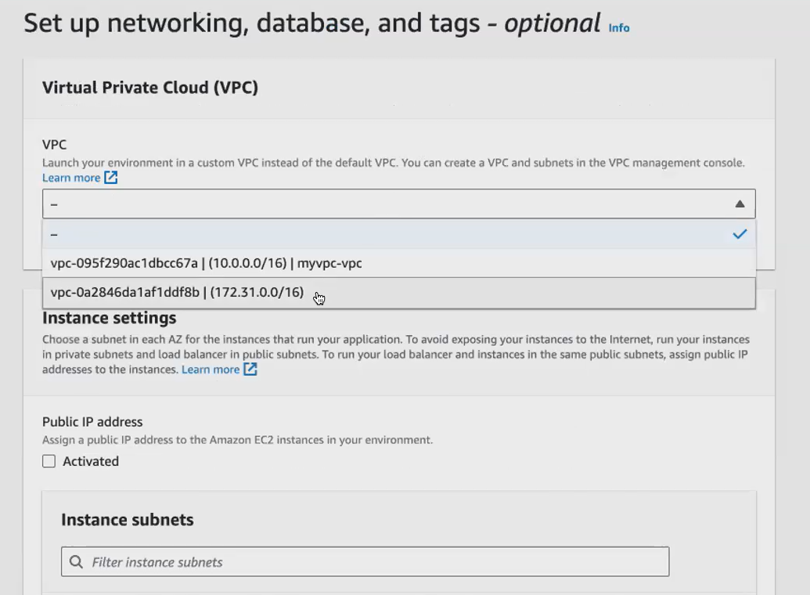

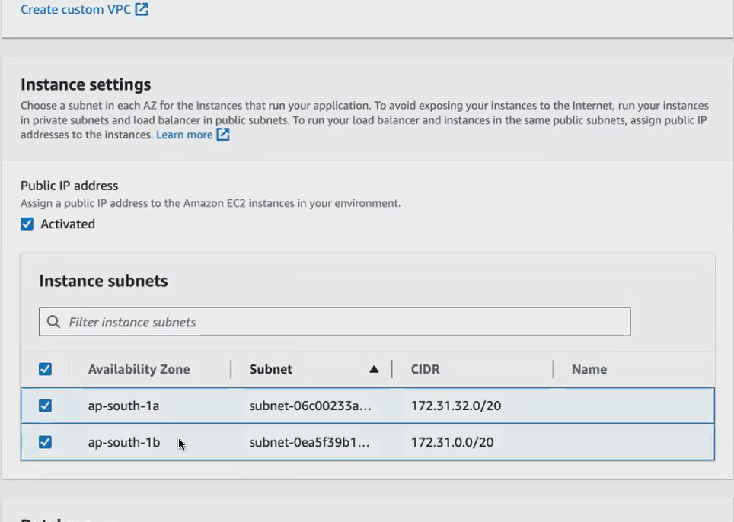

**Select default volume**

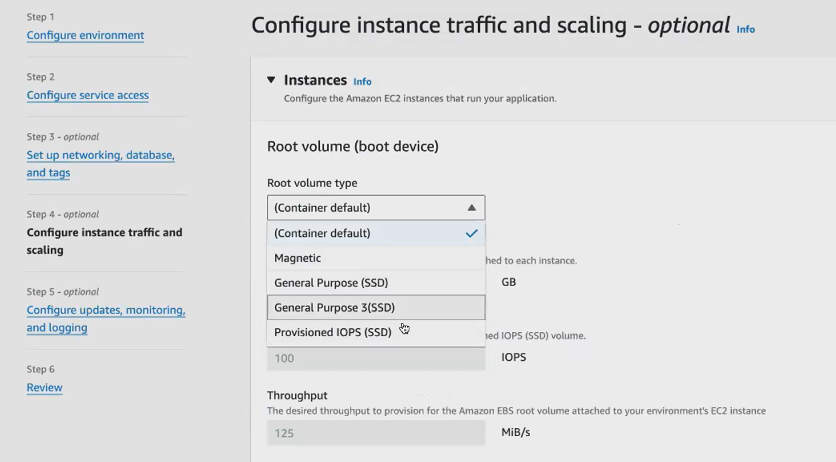

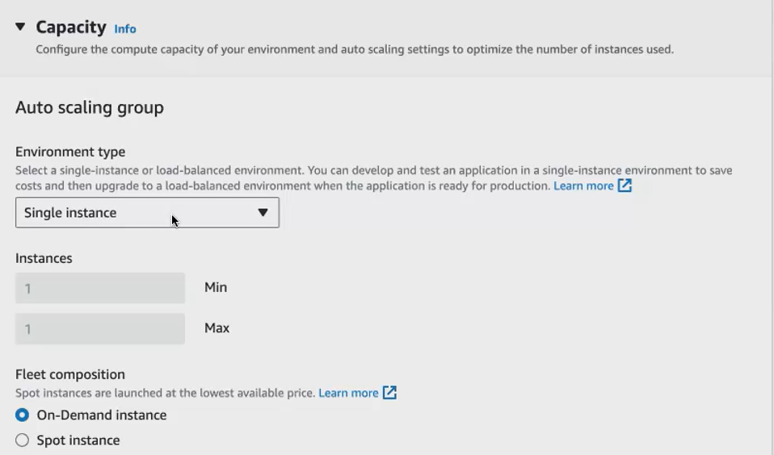

Your Elastic building stock will create an Ec 2 for you. So it will create in this architecture so it can either launch a t 3 micro or a t 3 small. Any one instance type will be launched with this ami id

Click next

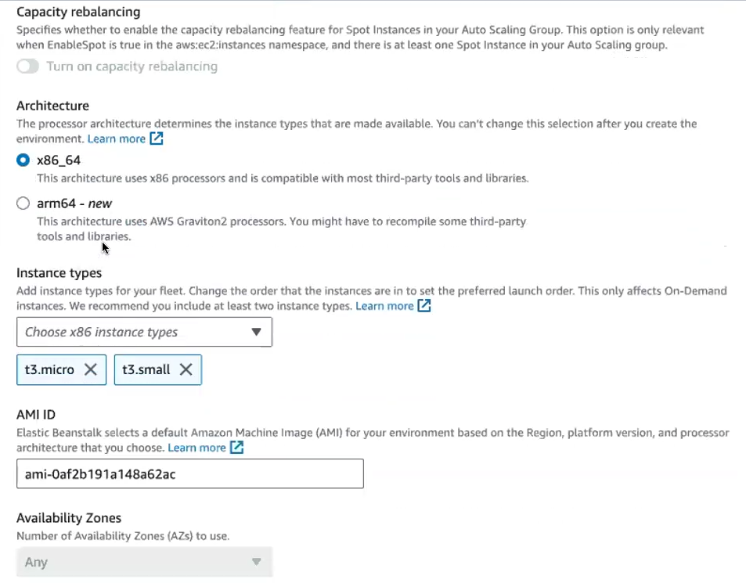

**I don't want to monitor it. Let me go with basics itself.**

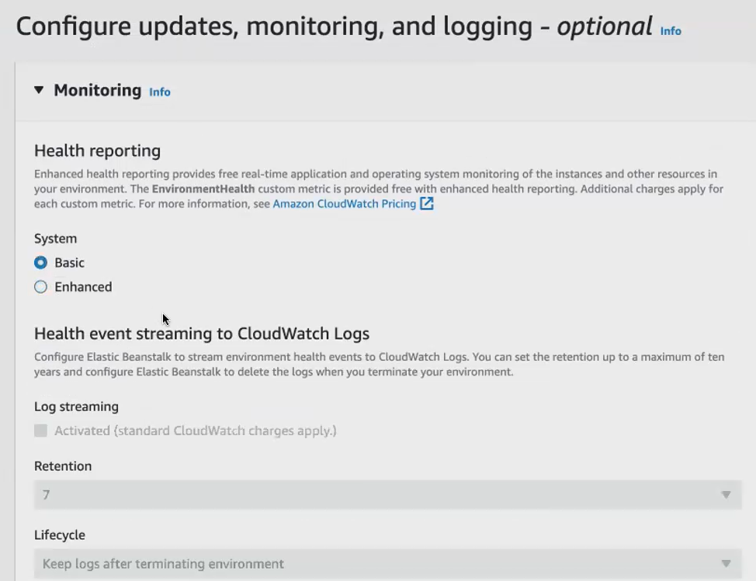

**Upadate the app give this.**

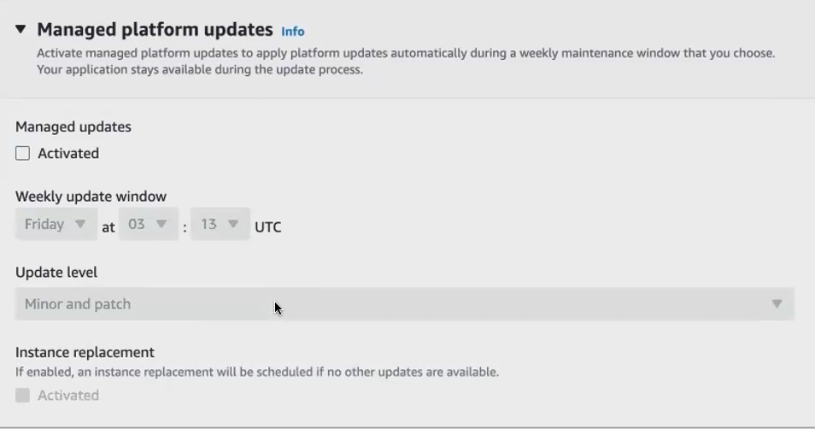

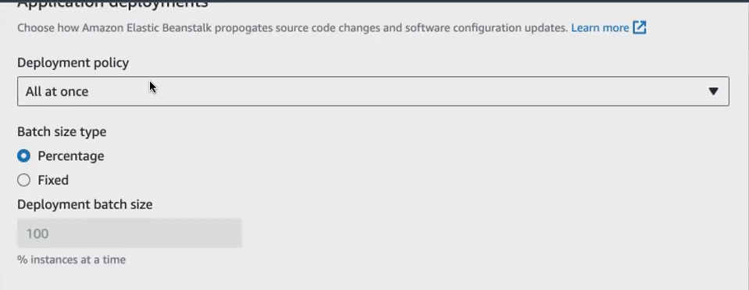

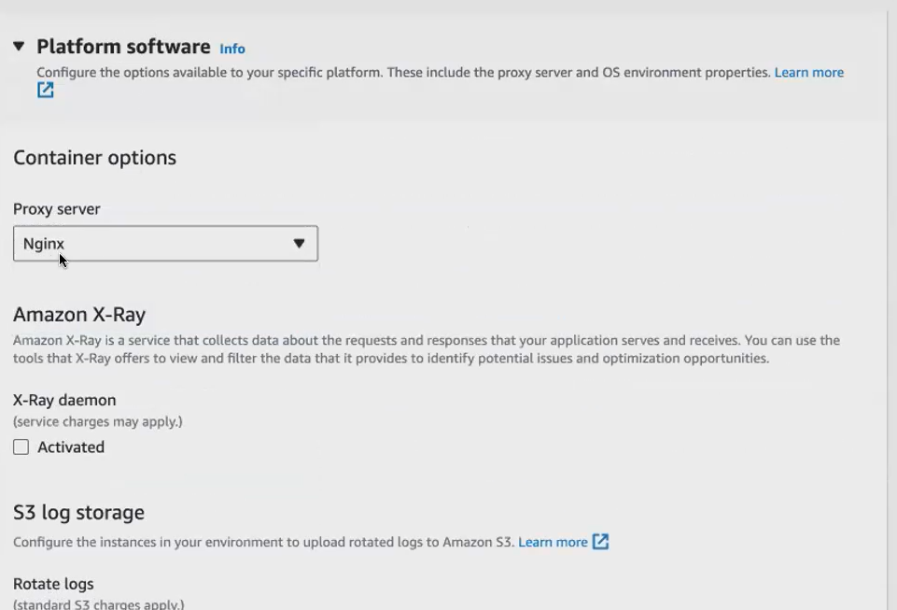

**I'm using Nodejs application, the proxy server, I think, for the Nodejs application. Your web server is going to be nginx. Okay to access your node. Js application in the browser.**

**Click next.**

**elasticbeanstalk will do**

* **It will launch an Ec2**
* **inside the Ec2 ,It will launch the platform. That is this platform. It will launch.**
* **It will install this platform after install this platform.**
* **It will upload your application into the plan into your Ec2.**
* **It will create auto scaling. It will create, load balancer. It will create cloud watch Everything will be launched by your elasticbeanstalk**

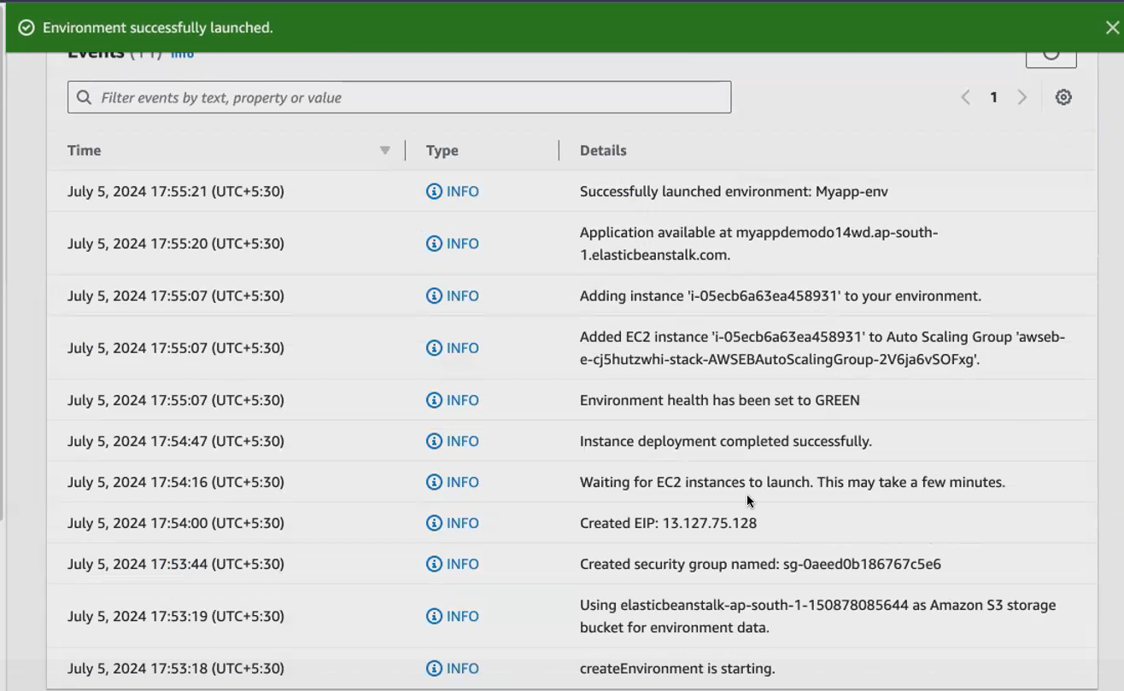

**How to access the application:**

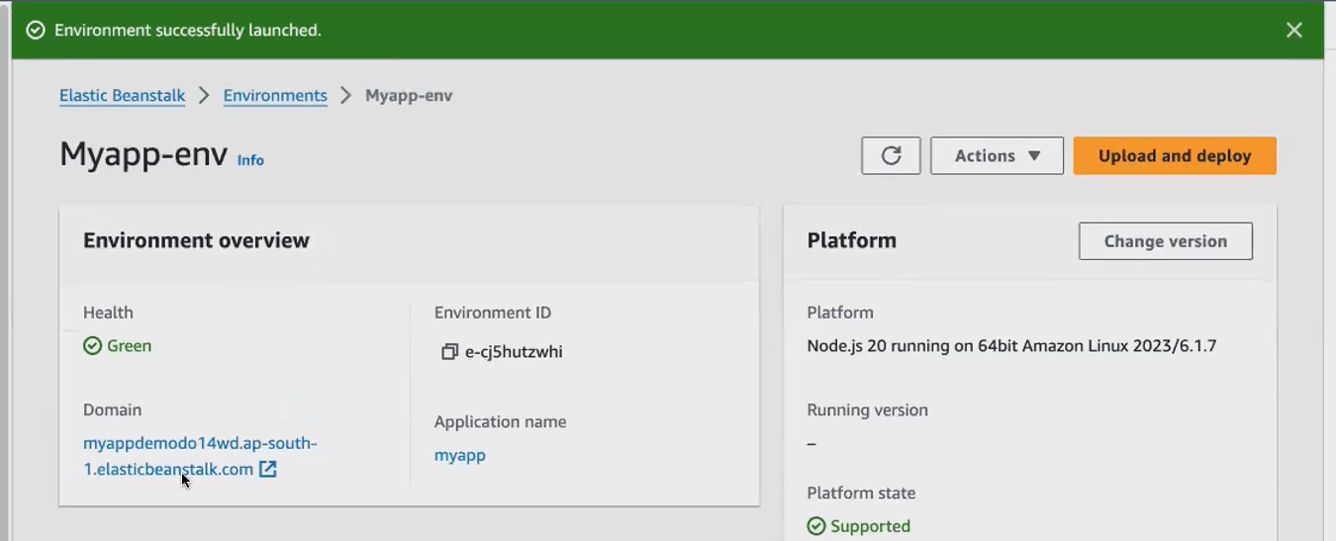

Click the domain name getinto the browser and open

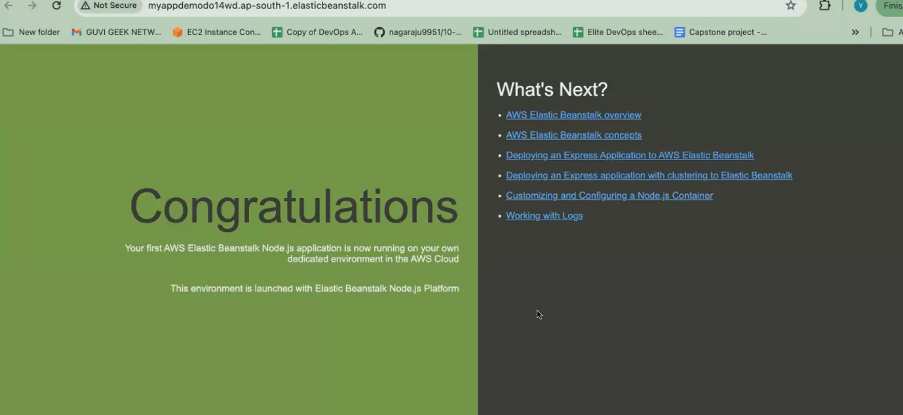

**You have launched the platform. If any chance, by any chance. If you have the application later, you can also click on upload and deploy. So you can just choose the file, choose our application, and you can deploy, you can click on the deploy. Your application will be deployed in the platform, in the environment.**

